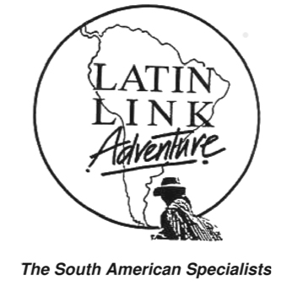
Latin Link Adventure
Latin Link Adventure have been operating to Galapagos and South America since 1992 and are dedicated to making travel to this delightfully chaotic continent – your trip of a lifetime. Our reputation has been built on providing safe, excellent value-for-money adventures.
Join one of our small group escorted tours or let us assist you of planning a tailor – made independent trip.
We are a New Zealand owned and operated company and support Friends of Galapagos NZ in their endeavours to support conservation and sustainable development in the Galapagos Islands.
Website: www.latinlink.co.nz
Ph 0800528465

